***Scientific Calculator***

*Made by: Group 11*

**

***Group Students***

|  |  |
| --- | --- |
| ***ID*** | ***Name*** |
| 6071 | 1-Ahmed Wael Mohamed |
| 6297 | 2- Adel Ashraf Mohamed |

***Content***

* Introduction about the program
* The program codes
* Problems encountered

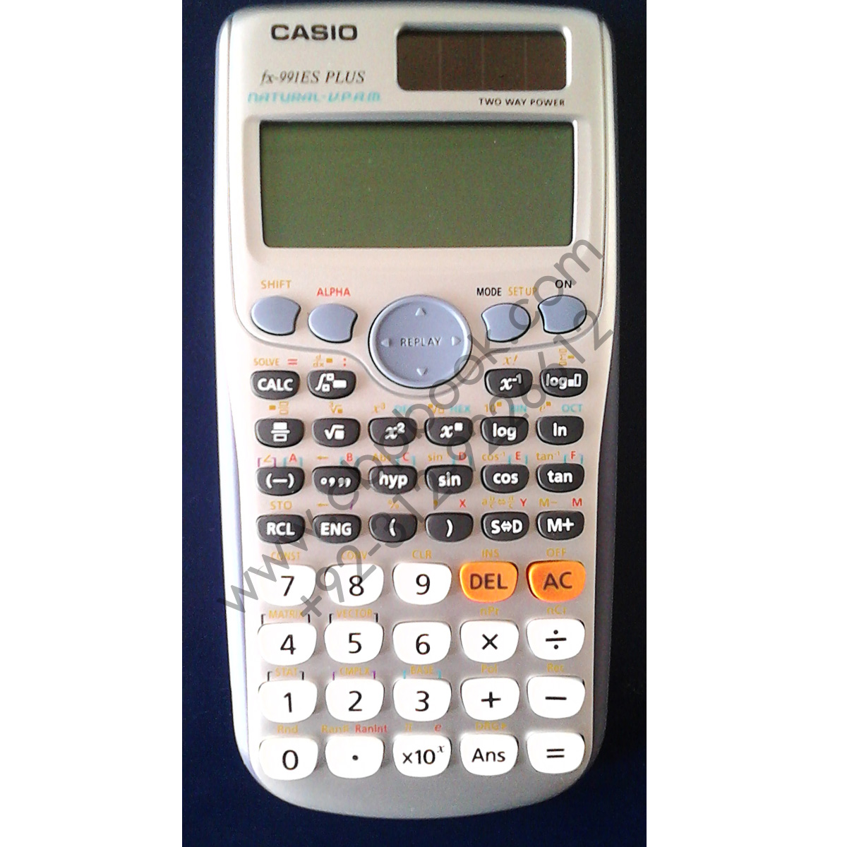

***First: Introduction***

The program is a basic and a scientific calculator which can make **basic features** as: logical operations, roots, factorial, absolute values, sign change, additive and multiplicative inverse, percent and changing from fraction to decimal and from decimal to fraction. The calculator can also make **scientific features** as: differentiation, integration, plotting, dealing with exponential, trigonometric, hyperbolic, logarithmic functions and solving equations.

***Second: The Program codes***

function varargout = calc(varargin)

gui_Singleton = 1;

gui_State = struct('gui_Name', mfilename, ...

'gui_Singleton', gui_Singleton, ...

'gui_OpeningFcn', @calc_OpeningFcn, ...

'gui_OutputFcn', @calc_OutputFcn, ...

'gui_LayoutFcn', [] , ...

'gui_Callback', []);

if nargin && ischar(varargin{1})

gui_State.gui_Callback = str2func(varargin{1});

end

if nargout

[varargout{1:nargout}] = gui_mainfcn(gui_State, varargin{:});

else

gui_mainfcn(gui_State, varargin{:});

end

function calc_OpeningFcn(hObject, ~, handles, varargin)

handles.output = hObject;

guidata(hObject, handles);

axes(handles.axes3)

matlabImage = imread('C:\Users\admin\Downloads\images 1.jpeg');

image(matlabImage)

axis off

axis image

function varargout = calc_OutputFcn(~, ~, handles)

varargout{1} = handles.output;

function four_Callback(~, ~, handles)

str=get(handles.inputastext,'string');

str=strcat(str,('4'));

set(handles.inputastext,'string',str);

function one_Callback(~, ~, handles)

str=get(handles.inputastext,'string');

str=strcat(str,('1'));

set(handles.inputastext,'string',str);

function zero_Callback(hObject, eventdata, handles)

str=get(handles.inputastext,'string');

str=strcat(str,('0'));

set(handles.inputastext,'string',str);

function three_Callback(hObject, eventdata, handles)

str=get(handles.inputastext,'string');

str=strcat(str,('3'));

set(handles.inputastext,'string',str);

function decimal_Callback(hObject, eventdata, handles)

str=get(handles.inputastext,'string');

str=strcat(str,('.'));

set(handles.inputastext,'string',str);

function six_Callback(hObject, eventdata, handles)

str=get(handles.inputastext,'string');

str=strcat(str,('6'));

set(handles.inputastext,'string',str);

function five_Callback(hObject, eventdata, handles)

str=get(handles.inputastext,'string');

str=strcat(str,('5'));

set(handles.inputastext,'string',str);

function two_Callback(hObject, eventdata, handles)

str=get(handles.inputastext,'string');

str=strcat(str,('2'));

set(handles.inputastext,'string',str);

function signchange_Callback(hObject, eventdata, handles)

str=get(handles.inputastext,'string');

s=str2double(str);

e=-(s);

t=num2str(e);

set(handles.inputastext,'string',t);

function seven_Callback(hObject, eventdata, handles)

str=get(handles.inputastext,'string');

str=strcat(str,('7'));

set(handles.inputastext,'string',str);

function nine_Callback(hObject, eventdata, handles)

str=get(handles.inputastext,'string');

str=strcat(str,('9'));

set(handles.inputastext,'string',str);

function eight_Callback(hObject, eventdata, handles)

str=get(handles.inputastext,'string');

str=strcat(str,('8'));

set(handles.inputastext,'string',str);

function add_Callback(hObject, eventdata, handles)

str=get(handles.inputastext,'string');

str=strcat(str,'+');

set(handles.inputastext,'string',str);

function sub_Callback(hObject, eventdata, handles)

str=get(handles.inputastext,'string');

str=strcat(str,'-');

set(handles.inputastext,'string',str);

function mul_Callback(hObject, eventdata, handles)

str=get(handles.inputastext,'string');

str=strcat(str,'*');

set(handles.inputastext,'string',str);

function div_Callback(hObject, eventdata, handles)

str=get(handles.inputastext,'string');

str=strcat(str,'/');

set(handles.inputastext,'string',str);

function Squareroot_Callback(hObject, eventdata, handles)

str=get(handles.inputastext,'string');

str=strcat(str,'sqrt(');

set(handles.inputastext,'string',str);

function percent_Callback(hObject, eventdata, handles)

str=get(handles.inputastext,'string');

s=str2double(str);

per=s/100;

t=num2str(per);

set(handles.textasoutput,'string',t);

function inverse_Callback(hObject, eventdata, handles)

str=get(handles.inputastext,'string');

str=strcat(str,'1/');

set(handles.inputastext,'string',str);

function equal_Callback(hObject, eventdata, handles)

str=get(handles.inputastext,'string');

str=eval(str);

set(handles.textasoutput,'string',str);

function clear_Callback(hObject, eventdata, handles)

set(handles.inputastext,'string','');

set(handles.textasoutput,'string','');

set(handles.edit1,'string','');

function derivative_Callback(hObject, eventdata, handles)

syms x;

input = get(handles.edit1, 'string');

input = strcat('@(x) ',input);

fx = str2func(input);

res = diff(fx,x);

set(handles.textasoutput, 'string', char(res));

function integration_Callback(hObject, eventdata, handles)

syms x;

input = get(handles.edit1, 'string');

input = strcat('@(x) ',input);

fx = str2func(input);

res = int(fx,x);

set(handles.textasoutput, 'string', char(res));

function plot_Callback(hObject, eventdata, handles)

a=get(handles.edit1,'string');

x = -5:0.1:5;

axes(handles.axes1)

comet(eval(a))

function solve_Callback(hObject, eventdata, handles)

syms x;

input = get(handles.edit1, 'string');

input = strcat('@(x) ',input);

fx = str2func(input);

res = solve(fx,x);

set(handles.textasoutput, 'string', char(res));

function cos_Callback(hObject, eventdata, handles)

str=get(handles.inputastext,'string');

str=strcat(str,'cosd(');

set(handles.inputastext,'string',str);

function power_Callback(hObject, eventdata, handles)

str=get(handles.inputastext,'string');

str=strcat(str,'^');

set(handles.inputastext,'string',str);

function bracket1_Callback(hObject, eventdata, handles)

str=get(handles.inputastext,'string');

str=strcat(str,('('));

set(handles.inputastext,'string',str);

function bracket2_Callback(hObject, eventdata, handles)

str=get(handles.inputastext,'string');

str=strcat(str,(')'));

set(handles.inputastext,'string',str);

function tan_Callback(hObject, eventdata, handles)

str=get(handles.inputastext,'string');

str=strcat(str,'tand(');

set(handles.inputastext,'string',str);

function sin_Callback(hObject, eventdata, handles)

str=get(handles.inputastext,'string');

str=strcat(str,'sind(');

set(handles.inputastext,'string',str);

function edit1_Callback(hObject, eventdata, handles)

function edit1_CreateFcn(hObject, eventdata, handles)

if ispc && isequal(get(hObject,'BackgroundColor'), get(0,'defaultUicontrolBackgroundColor'))

set(hObject,'BackgroundColor','white');

end

function pi_Callback(hObject, eventdata, handles)

str=get(handles.inputastext,'string');

str=strcat(str,('pi'));

set(handles.inputastext,'string',str);

function log_Callback(hObject, eventdata, handles)

str=get(handles.inputastext,'string');

str=strcat(str,'log10(');

set(handles.inputastext,'string',str);

function ln_Callback(hObject, eventdata, handles)

str=get(handles.inputastext,'string');

str=strcat(str,'log(');

set(handles.inputastext,'string',str);

function expo_Callback(hObject, eventdata, handles)

str=get(handles.inputastext,'string');

str=strcat(str,'exp(');

set(handles.inputastext,'string',str);

function root_Callback(hObject, eventdata, handles)

str=get(handles.inputastext,'string');

str=strcat(str,'^(1/');

set(handles.inputastext,'string',str);

function factorial_Callback(hObject, eventdata, handles)

str=get(handles.inputastext,'string');

str=strcat(str,'factorial(');

set(handles.inputastext,'string',str);

function Sinh_Callback(hObject, eventdata, handles)

str=get(handles.inputastext,'string');

str=strcat(str,'sinh(');

set(handles.inputastext,'string',str);

function Cosh_Callback(hObject, eventdata, handles)

str=get(handles.inputastext,'string');

str=strcat(str,'cosh(');

set(handles.inputastext,'string',str);

function Tanh_Callback(hObject, eventdata, handles)

str=get(handles.inputastext,'string');

str=strcat(str,'tanh(');

set(handles.inputastext,'string',str);

function Absolute_Callback(hObject, eventdata, handles)

str=get(handles.inputastext,'string');

str=strcat(str,'abs(');

set(handles.inputastext,'string',str);

function dtof_Callback(hObject, eventdata, handles)

str=get(handles.inputastext,'string');

str=strcat(str,'rat(');

set(handles.inputastext,'string',str);

function inversesin_Callback(hObject, eventdata, handles)

str=get(handles.inputastext,'string');

str=strcat(str,'asind(');

set(handles.inputastext,'string',str);

function inversecos_Callback(hObject, eventdata, handles)

str=get(handles.inputastext,'string');

str=strcat(str,'acosd(');

set(handles.inputastext,'string',str);

function inversetan_Callback(hObject, ~, handles)

str=get(handles.inputastext,'string');

str=strcat(str,'atand(');

set(handles.inputastext,'string',str);

function ftod_Callback(~, ~, handles)

str=get(handles.inputastext,'string');

str=strcat(str,'double(');

set(handles.inputastext,'string',str);

function tenpower_Callback(hObject, ~, handles)

str=get(handles.inputastext,'string');

str=strcat(str,'*10^');

set(handles.inputastext,'string',str);

***Third: Problems Encountered***

**We faced some problems in our program as:**

* Doing differentiation
* Doing integration
* Plotting
* Making the interface

**How we faced these problems:**

* As for the interface we got help from the YouTube about the work with the GUI
* As for the differentiation, integration, and plotting we referred to mathworks and what we have studied

(https://www.mathworks.com)